Звіт

про виконання практичної роботи 5

**Тема: Проектування лісосмуг**

На поставлені запитання дати відповіді:

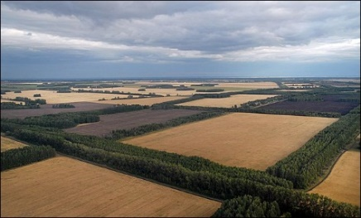

1. Дайте визначення полезахисних лісових смуг

Відповідь:___________________________________________________________________________________________________________________________________________________________________________________________________________________________________________________________________________________________________________________________________________

__________________________________________________________________________________________________________________________________________________________________________

__________________________________________________________________________________________________________________________________________________________________________

__________________________________________________________________________________________________________________________________________________________________________

__________________________________________________________________________________________________________________________________________________________________________

__________________________________________________________________________________________________________________________________________________________________________

_____________________________________________________________________________________

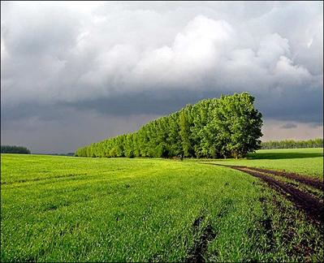

2. Охарактеризуйте полезахисну лісосмугу щільної конструкції

Відповідь:______________________________________________________________________________________________________________________________________________________________________________________________________________________________________________________

_____________________________________________________________________________________

_____________________________________________________________________________________

_____________________________________________________________________________________

_____________________________________________________________________________________

_____________________________________________________________________________________

_____________________________________________________________________________________

______________________________________________________________________________________________________________________________________________________________________________________________________________________________________________________________________________________________________________________________________________________________________________________________________________________________________________________________________________________________________________________________

_____________________________________________________________________________________

_____________________________________________________________________________________

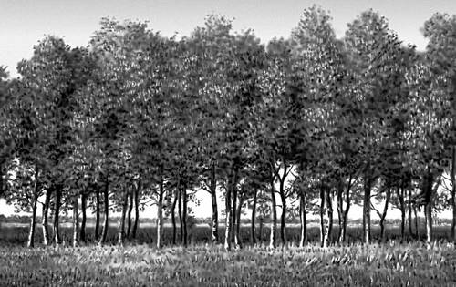

3. Охарактеризуйте полезахисну лісосмугу продувної конструкції

Відповідь:_________________________________________________________________________________________________________________________________________________________________

__________________________________________________________________________________________________________________________________________________________________________

__________________________________________________________________________________________________________________________________________________________________________

__________________________________________________________________________________________________________________________________________________________________________

__________________________________________________________________________________________________________________________________________________________________________

__________________________________________________________________________________________________________________________________________________________________________

__________________________________________________________________________________________________________________________________________________________________________

_________________________________________________________________________________________________________________________________________________________________________________________________________________________________________________________________________________________________________________________________________________________________________________________________________________________________________

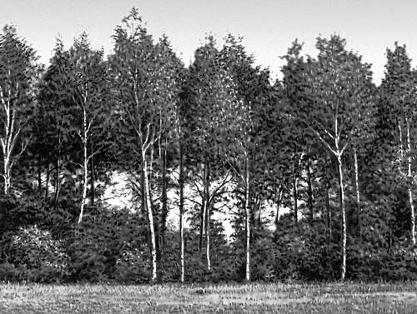

4. Охарактеризуйте полезахисну лісосмугу ажурної конструкції

Відповідь:_________________________________________________________________________________________________________________________________________________________________

_____________________________________________________________________________________________________________________________________________________________________________________________________________________________________________________________________________________________________________________________________________________________________________________________________________________________________________________________________________________________________________________________________________________________________________________________________________________________________________________________________________________________________________________________________________________________________________________________________________________________________________________________________________________________________________________________________________________________________________________________________________________________________________________________________________________________________________________________________________________________________________________________________________________________________________________________________________________________________________________________________________________________________________________________________________________________________________________________________________________________________

________________________________________________________________________________________________________________________________________________________________________

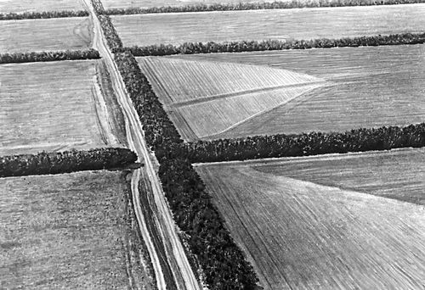5. Від яких факторів залежить ефективність дії лісосмуг?

Відповідь:________________________________________________________________________________________________________________________________________________________________

________________________________________________________________________________________________________________________________________________________________________

________________________________________________________________________________________________________________________________________________________________________

________________________________________________________________________________________________________________________________________________________________________

________________________________________________________________________________________________________________________________________________________________________

________________________________________________________________________________________________________________________________________________________________________

____________________________________________________________________________________________________________________________________________________________________________________________________________________________________________________________

________________________________________________________________________________________________________________________________________________________________________________________________________________________________________________________________________________________________________________________________________________

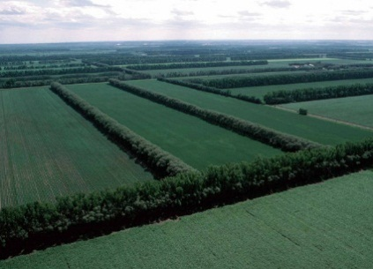

6. Охарактеризуйте основні (повздовжні) лісосмуги

Відповідь:________________________________________________________________________________________________________________________________________________________________

________________________________________________________________________________________________________________________________________________________________________

________________________________________________________________________________________________________________________________________________________________________

________________________________________________________________________________________________________________________________________________________________________

________________________________________________________________________________________________________________________________________________________________________

________________________________________________________________________________________________________________________________________________________________________

________________________________________________________________________________________________________________________________________________________________________________________________________________________________________________________________________________________________________________________________________________

7. Охарактеризуйте допоміжні (поперечні) лісосмуги

Відповідь:______________________________________________________________________ __________________________________________________________________________________________________________________________________________________________________________

________________________________________________________________________________________________________________________________________________________________________

________________________________________________________________________________________________________________________________________________________________________________________________________________________________________________________________________________________________________________________________________________

8. Перелічіть головні та супутні породи дерев, рекомендовані для насадження в південному степу

Відповідь:___________________________________________________________________________________________________________________________________________________________________________________________________________________________________________________________________________________________________________________________________________________________________________________________________________________________________________________________________________________________________________________________________________________________________________________________________________________________________________________________________________________________________________________________________________________________________________________________________________________________________________________________________

9. Яка рекомендована кількість рядів дерев у лісосмузі ажурної конструкції?

Відповідь:___________________________________________________________________________________________________________________________________________________________

_______________________________________________________________________________________________________________________________________________________________________________________________________________________________________________________________

10. Якою повинна бути ширина міжрядь у лісосмузі на чорноземах?

Відповідь:___________________________________________________________________________________________________________________________________________________________

__________________________________________________________________________________________________________________________________________________________________________

11. Яка повинна бути відстань між деревами в ряду?

Відповідь:___________________________________________________________________________________________________________________________________________________________

__________________________________________________________________________________________________________________________________________________________________________

12. Визначити потребу в садивному матеріалі для насадження основної лісосмуги ажурної конструкції довжиною 2500 м (шт.)

Відповідь:____________________________________________________________________________________________________________________________________________________________________________________________________________________________________________________________________________________________________________________________________________________________________________________________________________________________________________________________________________________________________________________________________________________________________________________________________

Висновок

Вказати, які знання та практичні навички набув студент після виконання практичної роботи:________________________________________________________________________________________________________________________________________________________________________________________________________________________________________________________________________________________________________________________________________________________________________________________________________________________________________________________________________________________________________________________________________________________________________________________________________________________________________________________________________________________________________________________________________________________________________________________________________________________________________________________________________________________________________________________________________________________________

Студент (ПІБ)____________________________________________________________________

Оцінка__________________________________________________________________________

Викладач _______________________________________________________________________