**Звіт**

про виконання практичної роботи 2

**Тема: Дощувальні машини та їх характеристика**

На поставлені запитання дати відповіді:

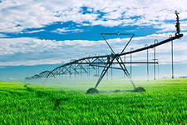

1. Перелічіть переваги зрошення дощуванням

Відповідь:_______________________________________________________________________ __________________________________________________________________________________________________________________________________________________________________________

__________________________________________________________________________________________________________________________________________________________________________

_________________________________________________________________________________________________________________________________________________________________________________________________________________________________________________________________________________________________________________________________________________________________________________________________________________________________________

_____________________________________________________________________________________

_____________________________________________________________________________________

_____________________________________________________________________________________

__________________________________________________________________________________________________________________________________________________________________________________________________________________________________________________________________________________________________________________________________________________________________________________________________________________________________________________________________________________________________________________________________________________________________________________________________________________________________________________________________________________________________________________________________________________________________________________________________________________________________________________________________________________

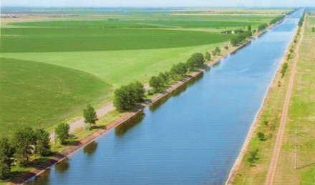

2. Перелічіть недоліки способу поливу дощуванням

Відповідь:____________________________________________________________________________________________________________________________________________________________

_______________________________________________________________________________________________________________________________________________________________________________________________________________________________________________________________

_____________________________________________________________________________________

__________________________________________________________________________________________________________________________________________________________________________

__________________________________________________________________________________________________________________________________________________________________________

__________________________________________________________________________________________________________________________________________________________________________

____________________________________________________________________________________________________________________________________________________________________________________________________________________________________________________________________________________________________________________________________________________

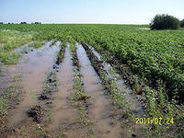

3. Вкажіть умови та область застосування зрошення дощуванням

Відповідь:_______________________________________________________________________ __________________________________________________________________________________________________________________________________________________________________________

__________________________________________________________________________________________________________________________________________________________________________

__________________________________________________________________________________________________________________________________________________________________________

__________________________________________________________________________________________________________________________________________________________________________

__________________________________________________________________________________________________________________________________________________________________________

__________________________________________________________________________________________________________________________________________________________________________

_______________________________________________________________________________________________________________________________________________________________________________________________________________________________________________________________

4. Як поділяються дощувальні машини залежно від дальності випадання дощу?

Відповідь:______________________________________________________________________ _______________________________________________________________________________________________________________________________________________________________________________________________________________________________________________________________

_______________________________________________________________________________________________________________________________________________________________________________________________________________________________________________________________

5. Як поділяються дощувальні машини за величиною напору води?

Відповідь:_______________________________________________________________________ _____________________________________________________________________________________ __________________________________________________________________________________________________________________________________________________________________________

__________________________________________________________________________________________________________________________________________________________________________

__________________________________________________________________________________________________________________________________________________________________________

__________________________________________________________________________________________________________________________________________________________________________

__________________________________________________________________________________________________________________________________________________________________________

__________________________________________________________________________________________________________________________________________________________________________

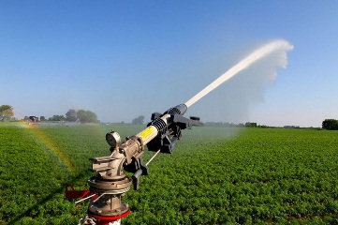

6. Перелічіть самохідні дощувальні машини

Відповідь:_______________________________________________________________________ _______________________________________________________________________________________________________________________________________________________________________________________________________________________________________________________________

__________________________________________________________________________________________________________________________________________________________________________

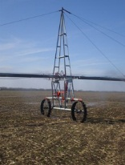

7. За рахунок чого відбувається рух дощувальної машини «Фрегат»?

Відповідь:_______________________________________________________________________ __________________________________________________________________________________________________________________________________________________________________________

__________________________________________________________________________________________________________________________________________________________________________

_____________________________________________________________________________________

__________________________________________________________________________________________________________________________________________________________________________

____________________________________________________________________________________________________________________________________________________________________________________________________________________________________________________________________________________________________________________________________________________

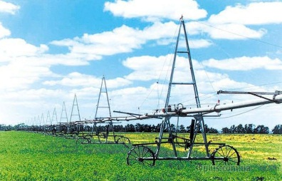

8. Опишіть характеристики дощувальної машини «Фрегат»

Відповідь:_______________________________________________________________________ _____________________________________________________________________________________

__________________________________________________________________________________________________________________________________________________________________________

__________________________________________________________________________________________________________________________________________________________________________

__________________________________________________________________________________________________________________________________________________________________________

__________________________________________________________________________________________________________________________________________________________________________

__________________________________________________________________________________________________________________________________________________________________________________________________________________________________________________________________________________________________________________________________________________________________________________________________________________________________________________________________________________________________________________________________________________________________________________________________________________________________________________________________________________________________________________________________________________________________________________________________________________________________________________________________________________

_____________________________________________________________________________________

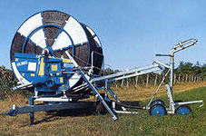

9. Опишіть характеристики дощувальних машин барабанного типу

Відповідь:_______________________________________________________________________ __________________________________________________________________________________________________________________________________________________________________________

__________________________________________________________________________________________________________________________________________________________________________

__________________________________________________________________________________________________________________________________________________________________________

__________________________________________________________________________________________________________________________________________________________________________

__________________________________________________________________________________________________________________________________________________________________________

__________________________________________________________________________________________________________________________________________________________________________

__________________________________________________________________________________________________________________________________________________________________________

__________________________________________________________________________________________________________________________________________________________________________

Висновок

Вказати, які знання та практичні навички набув студент після виконання практичної роботи: _____________________________________________________________________________________ __________________________________________________________________________________________________________________________________________________________________________________________________________________________________________________________________________________________________________________________________________________________________________________________________________________________________________________________________________________________________________________________________________________________________________________________________________________________________________________________________________________________________________________________________________________________________________________________________________________________________________________________________________________

Студент (ПІБ) _________________________________________________________________

Оцінка _______________________________________________________________________

Викладач ____________________________________________________________________